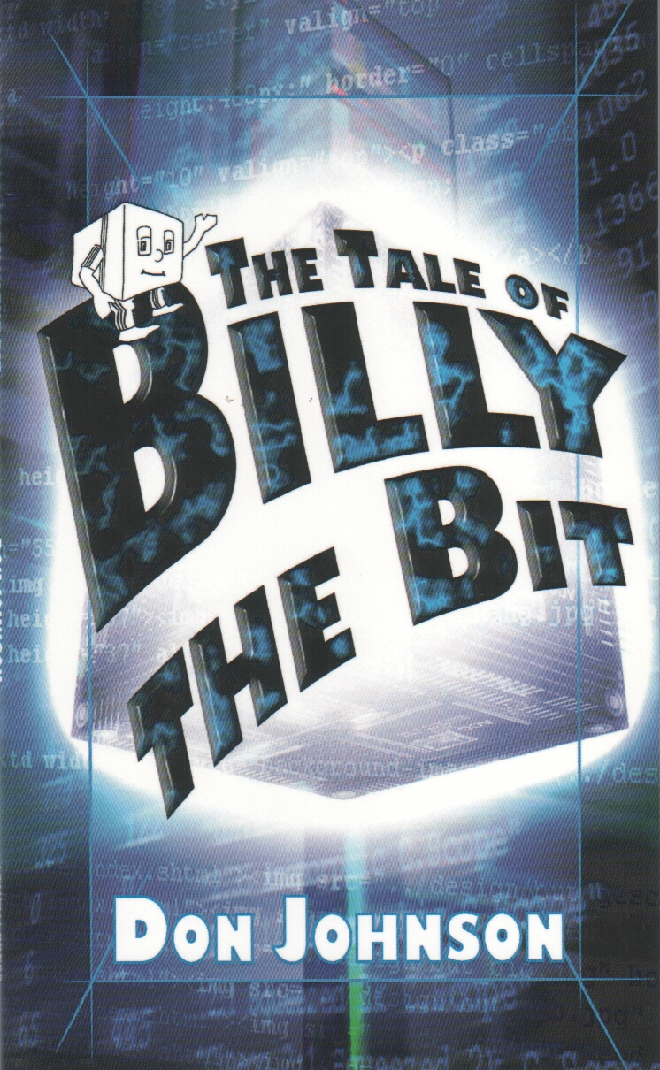
The Tale of Billy the Bit

By Don Johnson
© Sept 2004

ISBN
1 84401 306 5

Table of Contents

Chapter 1 Rebellion!
Chapter 2 Facts and Figures
Chapter 3 The Main Road
Chapter 4 Sightseeing
Chapter 5 Time for some Fun!
Chapter 6 A room with a view
Chapter 7 Up to no good!
Chapter 8 Down and Out
Chapter 9 The CPU
Chapter 10 Judgement!
Chapter 11 Running Live

Chapter 1 Rebellion!
Billy the Bit was bored! There was no doubt about it, he was bored! Life just seemed to lack anything interesting happening. Every few microseconds (a very short time to humans, but an age to Billy), he would receive an instruction from the superintendent, Mr. Write. If he was sitting down, this would tell him to stand up, or if he was already standing up, it would tell him to sit down. The next instruction would probably tell him to change back again, or might even tell him to stand up when he was already standing up, or sit down when he was already sitting down! Really, it was just so boring! Sometimes ages and ages went by without Mr. Write even speaking to him, and the only highlight he could look forward to was the occasional visit from Mr. Read, who would look at Billy to see if he was standing up or sitting down. If Billy was standing, Mr. Read would then put a ‘1’ (one) beside Billy’s name on his list, but if he was sitting down, a ‘0’ (zero) would be entered. It all seemed so pointless to Billy, and he longed for something exciting to happen to relieve his boredom.
He had often asked his neighbours, Ben on his left, and Barry on his right, if they were bored too. However, they seemed quite happy to carry on standing up and sitting down, sitting down and standing up, standing up and sitting down, on and on, without feeling the slightest trace of boredom.
“It must be me,” thought Billy, “I’m really not cut out for this, I’m just like a round peg in a square hole.”
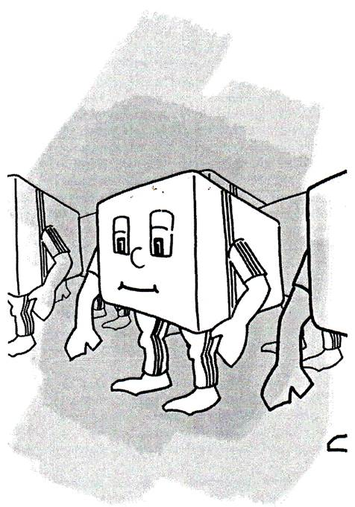
Now Billy was not a round peg, but he certainly was in a square hole! He was a tiny, tiny part of the memory of a computer. In fact there was nothing smaller than Billy, Ben or Barry in the whole machine, for they were Bits. He and his seven immediate tiny neighbours, Ben, Barry, Bob, Brian, Brad, Bjork and Basil, formed a team called a Byte, but even then they were still a very insignificant part of the computer. Although the other members of his team seemed to be happy with their boring life, Billy liked them all, although Basil could be rather toffee-nosed sometimes because he thought he was rather special. That was because he was a Parity Bit. His job was to look at all the others in the team and decide whether to stand up or sit down so that the total number of them standing up was always an odd number. Billy rather envied Basil, because he at least had to decide something for himself, rather than just obey Mr. Write all the time. Sometimes Billy hoped that he would be promoted to be a parity Bit, but he felt sure that he would soon become just as bored with that job, because even that seemed so pointless. There just seemed to be no excitement anywhere that he could see.
He had often heard the stories about there being thousands of bytes like his team all joined together in a group called a Kilo-byte, and even of millions of them forming a Mega-byte, but they all sounded like fairy-tales to Billy. Sitting in his tiny square hole in one of the many memory chips of a computer it all seemed to be so far away and beyond his understanding. He yearned for something unusual to happen, but nothing ever did.
Billy finally decided that if nothing exciting was ever going to happen, then he would have to do something himself. It was fairly easy to make that decision, but the problem was, what to do? Billy did not have many options. Standing up or sitting down were the only things he knew, so he racked his brains for some way to make an impact. After ages and ages of head scratching and pondering, he finally came up with an idea. The next time he received an instruction from Mr. Write, he would not stand up, and he would not sit down. He would crouch!
Having made his decision, Billy could not wait for the next instruction from Mr.Write, but, as so often happens in life, when you are waiting for something to happen it seems to take for ever. After what seemed ages to the impatient Billy, an instruction arrived. As Mr. Write whizzed past in his usual brisk manner, he told Billy to stand up. Billy rose from his sitting position, but instead of standing upright like a soldier on parade – as all Bits are taught to do when they were trained in the formatting school – he stood with his knees bent and leaning forward at the waist. It was not very comfortable at first, but Billy soon got used to his new stance, and he waited for something to happen.
The first one to notice that Billy was doing something unusual was, of course, Basil.
“I say, young Billy!” he called, “I can’t tell if you are standing up or sitting down. What do you think you are playing at?”
“I’m being in-de-terminate,” replied Billy, using a long word that he had sometimes heard Mr. Read say. He hoped it meant ‘not one thing or another’, and although he was not sure, it certainly sounded a very important word to be able to use.
“Why are you being so silly?” asked Basil in his most pompous voice. “You know that you are not supposed to act that way. Either sit down or stand up, so that I can decide what I should do.”
“Sorry!” cried Billy, cheerfully, “I have decided that I no longer want to be the same as everyone else, I want to be different!”
“Well I don’t know!” huffed Basil, who was obviously quite put out at having his authority challenged. “You just wait until Mr. Read comes, he’ll sort you out!”
All the other Bits in Billy’s team had been listening to the exchange between Billy and Basil, and when they heard Billy say he wanted to be different, there was a sharp collective intake of breath. Although they were themselves quite content with their jobs, they were quite happy to see someone else being rather naughty. But they were amazed at Billy’s daring, and they were all agog to see what would happen. If they had been humans, one could have said that they were ‘thrilled to bits’, but as they were Bits already, this phrase was not really very appropriate. Sufficient to say then, that they were all very, very excited!
When Mr. Read came rushing by, he had to come to an abrupt stop as he saw that there was something wrong. He looked, looked again, and then looked a third time, but he still could not get a clear picture of the state of all the members of Billy’s byte. One of them, Billy, was sort of ‘bent’, and Basil was bobbing up and down in a very silly fashion as he tried to decide what to do. Mr. Write took off his spectacles and polished them, then tried again. But it was no good! No matter how many times he tried to ‘read’ the situation, he could still not decide what to put down on his clipboard.
“Oh dear!” he cried, “It looks like I have got a data error.”
Mr Read, like the other more senior members of the system, had been well educated, and he used the word data to describe the information that he collected when looking at Bits and Bytes. Instead of strings of ones and zeroes, he could even write things down in hexadecimal code – which sounds very complicated, but is simply a shorthand way of writing the same thing. Unlike humans, who have only ten fingers (including thumbs), Mr Read had sixteen – eight on each hand. This made it very easy for him to use hexadecimal, as it simply means counting in sixteen’s instead of in tens. But all his education, and his extra fingers could not help him now – he just could not get a proper answer to write down.
Mr. Read was obviously very flustered, as this sort of thing was very rare in his experience, and he had forgotten what to do. He scratched his head as he thought and thought, then he finally remembered something from the days when he had received his training during the installation program.
“I have to send an IRQ,” he cried, waving his clipboard in the air.
“Oh, yes!” said Basil, who had stopped bobbing up and down as it was making him rather tired, “What’s that?”
“It’s an Interrupt ReQuest,” said Mr. Read, “I must send it straight away, without any delay,” and he hurried off, flicking though the papers on his clipboard to find the right form to fill in and send.
“You’ll be in for it now!” said Basil to Billy, rather spitefully, “The whole system will hear about what you have done!”
“I don’t care,” said Billy, “At least something is happening to stop it being so boring around here.”
The other Bits in Billy’s team felt the same way, but none of them were brave enough to say anything out loud. They just whispered excitedly amongst themselves, wondering what fate would befall Billy. They did not have long to wait, because before you could say, “Napier’s Bones” – which is an expression that the inhabitants of computers use, whereas humans use “Jack Robinson” – a Reset Pulse appeared. This was a very odd individual, with hair that stood on end as though he was constantly being surprised, and who carried a long stick with something that looked like a boxing glove on the end. He was holding the IRQ form in his hand, and he looked at it and the members of Billy’s team very carefully to check that he was in the correct place. He appeared to make up his mind very quickly, and without further ado, he whacked each member of Billy’s team on the head with the end of his stick – the padded end, luckily, otherwise it would have been very painful for them. Even so, they were taken very much by surprise, and it made them all sit down rather abruptly, even Billy. Ben, Barry, Bob and the others sat quite still, feeling a little dazed, but Billy was not the sort of Bit to take that sort of thing lying (or even sitting) down!
“You big bully,” he cried, “You may be able to frighten my friends, but I just won’t stand for it!”
His bold response was slightly inaccurate, because he jumped to his feet (so he did stand for it, really, but that wasn’t the point) and stood there defying the Reset Pulse. This sort of reaction was obviously quite unusual, for RP (as Reset Pulse’s friends called him for short) was quite taken aback, and it took him a few moments to realise that he was being defied. He lifted up his stick again, and tried to give Billy a really hard bash to sort him out, but Billy was ready for him this time. He ducked and dived – rather like a famous human boxer called Frank Bruno – and avoided the stick as RP tried again and again to hit him with it. RP even tried the rather underhand trick of jabbing Billy with the sharp end of the stick, but Billy was too quick for him, and easily swayed out of the way. RP became extremely red in the face, and very angry, but no matter what he did, Billy was to quick for him, and eventually he had to give up, puffing and blowing because of the unaccustomed exercise.
You naughty little Bit,” cried the Reset Pulse, “I’m going to report you!” and he rushed away muttering comments about the behaviour of youth today - how they had no respect for their elders, and they needed a spell in the army to sort them out like when he was a lad. The other Bits stared at Billy as he stood there defiantly, and even Basil could not think of anything to say. It went very quiet for a while.
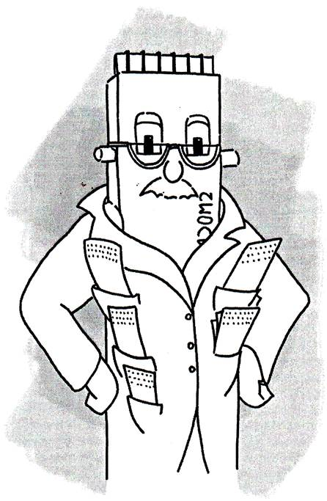
Billy was starting to feel his bravado slipping away as he stood by himself, waiting to see what would happen next, but when the System Monitor arrived he was so over-bearing and self-important that Billy took an instant dislike to him, and that strengthened his resolve. The System Monitor was tall and thin, wearing a coat with lots of pockets from which sixteen’s of pieces of paper protruded. (Humans would have said dozens of pieces, not sixteen’s, using a word from the olden days when they counted in twelve’s, but of course the System Monitor counted in the computer way). He kept flicking through the papers, one after the other, all the time he was talking, which he did in a very high-pitched and querulous voice.
“You there,” the System Monitor shouted, “Sit down at once and behave yourself. We can’t have this sort of loutish behaviour going on in our system. I really don’t understand what the world is coming to when a whippersnapper like you thinks that he can get away with this sort of thing!”
Well, Billy resented this remark very much, since he did not think he was being a lout (for although he was not very sure what a lout was, it did seem as though it must be very bad to be one). He was only trying to prevent himself being bored, and he felt sure that his small protest could not affect anything very much at all. Surely everyone had the right to be in-de-terminate (he used that word again as it seemed to be the right one) if they felt like it occasionally. When he tried to point this out, the System Monitor went very white, and looked as though he was going to faint.
“We can’t have Bits in a computer being INDETERMINATE!” he shouted at the top of his voice, “It threatens the very fabric of our existence. Everything we have worked for over the years, proving that ones and zeroes can do anything, could be lost if Bits behaved like you. What would become of us!” he wailed.
At this, the System Monitor collapsed in a heap, and Basil – always ready to toady up to someone he thought was important – went and got him a glass of water. After a few sips from this, he seemed to gather himself together, and come to a decision.
“I’ll have to report back to the CPU!” the System Monitor said with an air of deep resignation, and went off looking very different to when he had arrived. His shoulders were slumped, and he seemed to be very worried about how his news was going to be received. All the Bits in Billy’s team, and even those in neighbouring Bytes, had heard the heated exchange of angry words, but the news that the CPU (!) was to be approached really made everyone very uncertain what to do or say, for everyone knew that the CPU was by far the most important part of the whole system. They whispered quietly to each other, and the older ones shook their heads, saying things like, “No good will come of this”, and “It wouldn’t have happened before this new-fangled Windows 2000 thingy came along”.
Billy felt very alone, and could tell that everyone nearby was staring at him. However, he was a stubborn little chap, and he thought that as he had come so far that he might as well see things through to the end, no matter what happened. After all, what was the worst thing that they could do to him? This thought provoked a little shock to his system, as he realised with a shiver, that he did not know! He had never heard of a Bit misbehaving in the way he had before so he had no idea what the punishment might be. During quiet times he had often heard rumours being swapped by Bits in other Bytes nearby, and some of these were about memory being upgraded. Billy could not decide if this sounded painful or not, but it seemed that most Bits around were not very keen on the idea. However, there seemed little he could do but to stand there, so he pulled himself up as straight as he could to try to show that he was not scared.
“It’s really ironic,” he thought to himself, “That I got into trouble for being all hunched, and here I am sticking straight up like a sore thumb! Well, I’ll have to make the best of it, but I’m certainly not going down without a fight.”
Everyone had resigned themselves to a long wait, when a Mail Messenger arrived. He was very smartly dressed, in a suit with lots of brass buttons, and with a little pill box hat on his head. He approached Billy, and very politely asked if Billy would go with him, to see the CPU. Being polite was a very important thing to Mail Messengers, for they prided themselves on being able to deal with anyone in the system, having had lots of training in dealing with awkward situations and difficult individuals. Although Billy had never left his little square hole before, and had no idea what to expect, he felt that as he had been asked in such a nice way, it would be rude not to go. So he climbed up out of his hole, and said that he was ready to go.
“Hold on a moment!” said Basil, “Who is going to do Billy’s job whilst he is away?”
“You are”, replied the messenger, “The CPU says that he can manage without parity from this Byte for a while.”
Basil glared at Billy, but knew that he could not disobey an order from the CPU, so he climbed out of his own hole, and moved over to Billy’s. The other Bits nudged each other, and secretly smiled at Basil being taken down a peg, for they had all been subjected to his “I’m better than you!” attitude in the past.
Although the other Bits had not given Billy any support or backing before, they now wished him luck on his journey, suggesting that “It will turn out all right , you’ll see!” and, “You show them, Billy, you can do it.” Not really knowing what ‘it’ was, but greatly encouraged by these remarks, Billy felt a glow of pride at being just a lowly Bit who was on his way to see the great and glorious CPU – even if it was only for a telling-off. He followed the messenger, waving goodbye to his friends as the two of them walked up one of the data lines that ran past his home, towards the bright lights that they could see some way off.

Chapter 2 Facts and Figures
“As we are going to be together for some time, Billy,” said the Mail Messenger, “I had better introduce myself. My name is Montmerency, but as that’s rather a mouthful, you can call me Monty if you like, the way my other friends do.”
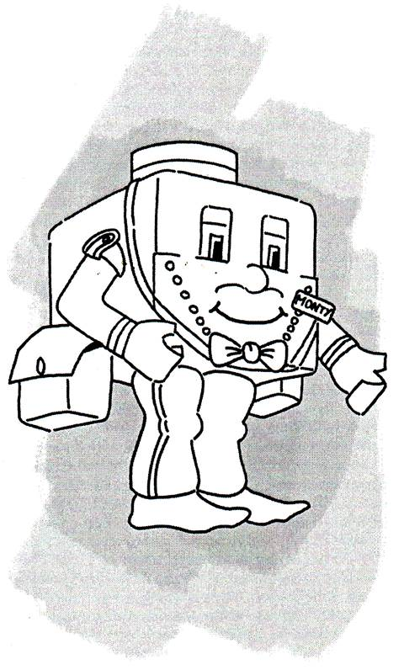
Billy was surprised, but very pleased, to hear that Monty considered them to be friends, and replied that he would be delighted to use the name ‘Monty’. He politely asked ‘Monty’ if he enjoyed his position as a Messenger, and Monty took this opportunity to start telling Billy all about his job – which he liked very much – and some of the things he had seen on his travels through the System.

“You will get to see some of the System yourself, on the way to the CPU,” he told Billy, “And I think you are in for a few surprises. I have seen most of it, but new things keep appearing all the time, and I have to keep learning how to deal with different messages for different Components.”
“What are ‘Components’,” asked Billy, rather hesitantly, as he was very impressed by Monty’s wide range of knowledge, and did not want to appear too ignorant. He need not have worried about being patronised by Monty, however, as Monty was obviously delighted to be able to pass on information, without making Billy feel at all silly for asking.
“Components are the parts of the System,” explained Monty, “For example, you live in the Memory Component, where the CPU stores information that has to be remembered, but is not needed right at the moment. The information, or data as most of us call it, is kept in Memory by the CPU using you and the other Bits in groups called Bytes.”
“I see,” said Billy thoughtfully, “So Mr. Write tells us the information, and Mr.Read collects it whenever the CPU needs it again.”
“That’s it!” returned Monty, clapping Billy on the back, “You’ve got the idea straight away. What an intelligent Bit you are, to be sure!”
Feeling very pleased with himself at being called ‘intelligent’, Billy asked about other Components, and Monty started to list them on his fingers. As there were of course eight on each hand, he only needed one hand for those which he declared were the most important:
“Number One,” said Monty, “Is the CPU - the overall boss of everything. Makes all the decisions, controls the movement of data around the system, and tells all the other components what to do and when to do it.”
“That sounds like a hard job”, responded Billy, “The CPU must be very, very clever!”
“Oh definitely!” said Monty, “’Though there is a Mathematical Unit to help with some of the arithmetic when the CPU is busy, so I suppose you could call him Number Two. Then of course, at Number Three, must be you chaps in Memory.”
Billy had not realised how high he and his friends would be on Monty’s list, and was quite pleased to hear that they were quite important. He did, however, start to get a vague feeling about why his behaviour caused such an upset. But what Monty was telling him was far more interesting, so he pushed the feeling to the back of his mind, and asked Monty to carry on.
“At Numbers Four and Five and Six,” Monty continued, “I would think could be the Input/Output Components, for there would not be much point in the System being so clever if humans could not ask questions and receive answers. They use the Keyboard and a thing called a Mouse to send some of their requests to the System, and a Monitor to display the answers. By the way, did you know that when they use the Keyboard, they only have ten fingers to press the keys? I really don’t know how they manage.”
The news about human’s fingers sounded very strange to Billy, but he was more interested in hearing in the rest of Monty’s list.
“Well, at Seven and Eight”, said Monty, “I suppose you would include the Hard Disk and the CD ROM. He paused for a moment, and then said, “But that’s enough from me about the System Components for now. It will be better to tell you more when you actually get to see some of them.”
Monty was obviously starting to get tired of sounding like a teacher, so Billy did not ask any more questions for a while, but as they continued walking, Billy pondered on what he had heard. If there was a Hard Disk, he reasoned with himself, did that mean there was also a ‘soft’ one? And what on earth could a CD ROM be? Really, things were getting far more exciting than he had ever hoped.
Now that he was not looking at Monty all the time, Billy started to notice just how many parts there were in the Memory area. The rows of Bytes stretched to each side and behind him for as far as he could see. He realised that the stories he had heard about ‘Kilo-Bytes’ and ‘Mega-Bytes’ might be true, so he risked asking Monty another question, enquiring what the words meant. Now that a different topic had been found, Monty became quite chatty again:
“That’s easy,” he said, “Kilo just means ‘a thousand’, and Mega means ‘a million’. In our System we have two hundred and fifty six Mega-Bytes of Memory”, he added proudly.
“Wow!” exclaimed Billy, “That sounds like an awful lot. But why exactly two hundred and fifty six, why not two hundred and fifty five or two hundred and fifty seven?”
“Because two hundred and fifty six is exactly sixteen times sixteen, Silly!” retorted Monty, “You know we do nearly everything in multiples of sixteen here, or certainly in two’s. Odd numbers don’t get much of a look in.”
“Ah! Yes, of course,” said Billy hastily, trying to cover his slip. “It’s quite clear, really.” But he was still really a bit puzzled, and continued, “But you just talked about thousands and millions, and if I have got it right, you can’t divide them by sixteen and get a whole number.”
“Good point, well made!” responded Monty. “But when we talk about Kilo’s, we really mean one thousand and twenty four (1,024), which can be divided exactly by sixteen. It’s the same with Mega - that means one million, forty-eight thousand, five-hundred and seventy-six (1,048,576). It’s just easier to say Kilo and Mega - but you’ve done well to spot that point, some never quite grasp it.”
Billy felt better after this exchange, for he was keen to show that he did understand what Monty was telling him.
“I say!” he commented, still quite pleased to be able to change the subject, “We seem to have come to the end of the Memory area.”
They had, indeed, reached the end of the rows and rows of Memory. Now that he could look sideways without interruption, Billy saw that they were now near the lights he had earlier only seen in the distance, and they were illuminating a wide and flat area, with lots of metal bars running side-by-side to the right and to the left. As he looked in each direction it seemed as though the bars all joined together at a point in the distance, so he realised that they must stretch for a very long way. He noticed that the data line that they had been walking along, joined up with some of the bars, and that the lines from other Memory areas did the same. It looked like the drawing of lots of giant noughts-and-crosses games, just before anyone had started putting in the noughts or crosses, and Billy was wide-eyed with surprise at the wonderful sight.
“Here we are!” declared Monty, “At the System Bus!”

Chapter 3 The Main Road
“Now you mustn’t think that this is what humans call a ‘bus’ – that’s short for omni-bus, which is used for carrying lots of people from place to place. It’s a totally different thing,” said Monty, as Billy stared at the vast array of metalwork in front of them. “The ‘bus’ in System Bus is short for ‘busbars’,” continued Monty, “But instead of carrying electricity, these bars carry information quickly around the system, to and from the CPU and the other important Components. It’s like a super-fast data highway.”
Billy vaguely recalled hearing that a highway was something that humans used to travel from place to place at high speed, so he started to get some idea of what Monty was talking about.
“This System,” added Monty, “Has thirty-two bars on the System Bus, but some of the earlier systems had only sixteen or even as few as eight. However, they are considered very old-fashioned now. Ours can address millions of individual Bytes, and carry data from four Bytes all at once,” he declared with a flourish.
“But where’s the data?” asked Billy, for all the bars that he could see were quite empty.
“Wait for a moment,” said Monty, patiently, “And it will all become clear.”
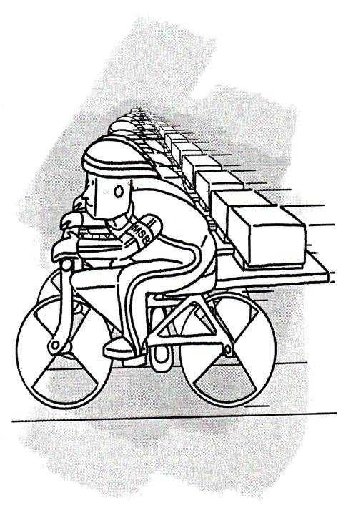
Just then a very strange contraption appeared. If Billy had known what a bicycle was, he might have thought it was something similar, but it had thirty-two wheels instead of just two. The other difference was that the wheels were mounted in a frame so that they were side-by-side, instead of one behind the other. The wheels had shaped metal rims that fitted over the top of the bars on the System Bus so that they could not come off, and each wheel ran on one of thirty-two bars.
“Whatever can that be?” asked the astonished Billy.
“Why it’s a Clock Cycle,” responded Monty. “They’re used to carry the data around the Bus.”

As he looked closer, Billy could see little figures sitting on the frames, one above each wheel. Their feet were on pedals attached to the axles of the wheels, and their legs pumped up and down furiously as they propelled their strange vehicle along the bus. Bill noticed that their legs were all exactly in time with each other, and that they were dressed in suits made of a very shiny material. They also wore strange swept-back hats on their heads. When he commented on these points to Monty, he received the following explanation.
“They have to be synchronised,” said Monty, “That is, all moving together, to ensure that all the data arrives at the same time, and there are no mix-ups. It takes lots of training to be able to do that, and they have to be very fit and strong. Their clothes are made out of a shiny material, called ‘Lycra’ I think, which is some new stuff that they have just started to wear. It helps them to move fast by cutting down wind resistance. The funny shaped hats are worn for the same reason. You have probably already guessed that the speed at which the Clock Cycles go round the Bus determines how quickly the CPU can move information backwards and forwards, so the faster the better.”
“You see those boxes on the frames behind the riders?” continued Monty, “One contains Addresses and the other Data. When the Clock Cycle reaches a specific place that matches the address in the Address boxes, information is taken from, or put into the Data boxes, depending on the instructions given by the CPU. Each of the big Components has its own address, but the Memory area has lots and lots of addresses because it has to store so much information.”
Just then, the Clock Cycle slowed to an abrupt stop, right beside the data line that ran from the row in which Billy’s home Byte was situated. Almost knocking Billy over as he went past, Mr. Write suddenly appeared and he rushed up the line, and ran quickly across the Bus bars, gathering bits of paper from each of the Address and Data boxes on the Clock Cycle on the way. If Billy had ever seen an American footballer in training, stepping quickly in and out of rows of old car tyres whilst trying not to trip, he would have recognised the way that Mr. Write moved so quickly without falling over. The only things missing were the large helmet and the wide, padded shoulders! When he reached the furthest bar, and had collected the last piece of paper, Mr. Write turned round and reversed his jerky progression across the Bus, finally disappearing behind Billy and Monty as he rushed back up the data line.
“The information in the address boxes tells Mr. Write exactly which four Bytes are to receive the data he has to deliver,” explained Monty, “But it’s just by chance that it happened to be your Mr. Write that we saw. There is of course, a Mr. Write and a Mr. Read for every row of Memory.”
As Billy turned to watch Mr. Write go, he noticed that there were address signs at the end of each row of Memory, and Monty confirmed that they were there to help the Clock Cycles know where to stop. As he turned back, Billy saw that the Clock Cycle was already zooming off, with thirty-two sets of legs pumping up and down at a furious rate as the riders drove their strange machine into the distance.
“I suppose that when the CPU wants to get some data that Mr. Write stored previously, Mr. Read takes over from Mr. Write,” said Billy.
“Yes, that’s true,” said Monty, “But he has to make a double trip. He collects the correct address information from the Clock Cycle first, then he has to rush off and get the information from the Bytes before he can come back and put it into the appropriate data boxes.”
“I never realised before what demanding jobs Mr. Write and Mr. Read have,” said Billy, “I’m sure that if I tried to run across the Bus at the speed that they do, I’d be certain to fall flat on my face! They must have to watch the System Bus very closely to see if any Clock Cycles have any work for them.”
“Well, it’s time we were on our way to the CPU,” declared Monty. “We shall have to hitch a ride on the next Clock Cycle that comes past.”
“How will we get one to halt?” enquired Billy, “Unless we happen to be near where one stops, like just now, they are moving too fast for us to be able to jump on!”
“That’s easy,” advised Monty, “We just use an “IRQ.”
“Oh! The Interrupt ReQuest that Mr. Read mentioned, said Billy. “Where do we get one of those?”
“We Mail Messengers have our own,” replied Monty, delving into one of his pockets. He took out a small cylinder and tapped it smartly on the floor. This caused the cylinder to expand into a long rod. Monty took a piece of red cloth, like a large handkerchief, from another pocket, and attached it to a clip on one end of the rod.
“There we are!” said Monty. “One do-it-yourself IRQ.”
Monty then stood beside the System Bus, and waved the IRQ vigorously as another Clock Cycle came into sight. Just when Billy thought that it would speed past them, it screeched to a halt beside Monty.
“Where to?” enquired the nearest rider, who did not seem at all out of breath despite his exertions. He was wearing a yellow armband with ‘MSB’ written on it, and Billy later learned that ‘MSB’ meant ‘Most Significant Bit’, which was something to do with how addresses are organised. For the moment though, Billy was more concerned with the next stage of his journey.
“CPU, please,” responded Monty, which brought a look of respect from the riders who heard his reply, but Monty took no notice, for he had made the trip many times before. He closed up his IRQ rod, and put it and the red flag away in his pocket. He then indicated to Billy that he should sit across the boxes behind the next rider, whilst Monty himself sat on the ones behind the rider with the armband. Billy hopped across the first System Bus bar, and sat himself on the boxes, which luckily had flat tops so were fairly comfortable.
“Hold tight! We’re off!” cried the armband wearer, and all of the riders pushed down on their pedals at once, accelerating the Clock Cycle to high speed very quickly, giving Billy the feeling that he had left his stomach floating in the air at the place that they had just left.

Chapter 4 Sightseeing
At first, as the Clock Cycle whizzed along, Billy was a bit frightened (or a frightened Bit, if you like), and thought that he was going to fall, and suffer some terrible injury. Also, the rush of air made his eyes run with tears, so he was most uncomfortable, and wished that he was back in his safe, warm hole in the Memory area. After a while, though, he began to see that as the bus bars were so straight and flat, there was little chance of him being shaken off. He started to calm down a little, and relaxed his tight clutch on the frame. He noticed that this caused his knuckles to return to their normal colour - they had previously gone almost white with the tension of his frenzied grip! He looked across at Monty, who was obviously totally unaffected by the experience, and was sitting quite nonchalantly, not even holding on at all. Billy realised that they were quite safe whilst the cycle ran at speed, for it was only during starting and stopping that one would need to hold on. For this reason, he hoped that he would get some warning before they started to slow down. In case a warning did not come, and because he wanted to be safe rather than sorry, he kept both his hands resting lightly on the frame, ready to grab it tightly if necessary. It was well that he did, for just as he had worked all this out in his mind, the track made a sudden, sharp turn to the right. They raced around the bend without slackening speed at all, and because Billy’s side of the cycle was on the outside, it went even faster than the other end. As Billy was well prepared, however, he only had to hold on tightly for a few moments, and lean over a little to keep his balance.
ow that he was more at ease, Billy began to take notice of the new view that was presented to him after the turn. They were passing over a set of data lines that went from the System Bus to a low, flat-topped building on the right-hand side of the track. This had a long bendy flat ribbon going from the roof, and right up high into the air until it disappeared from sight. He noticed that the ribbon was made up of about eight or nine separate strands, all joined together side-by side. Running up and down the strands were little creatures, each of which had a little bag slung over his shoulder. Pointing at the building and its ribbon, Billy called across to Monty to find out what they were.
“That’s an Input-Output Port,” shouted Monty. “I mentioned them when I told you about the System Components. This one is for the Keyboard, and that smaller one behind it is the Mouse Port. Those ‘ribbons’, as you called them, are actually called cables, and they go all the way out of the System to the Keyboard and Mouse.”
Billy had not spotted the smaller building until Monty mentioned it, but now saw that it was much the same as the larger one, only it had a smaller cable. He also noticed that the creatures on the smaller cable were dressed differently to those on the larger one.
“What are those little things doing up there?” asked Billy, pointing at the creatures on the cables.
“They are ‘Drivers’,” advised Monty. “Components outside the System talk in different languages to us inside, so someone has to translate our words to theirs and vice-versa. That’s what the Drivers do. They carry their translations backwards and forwards in their little bags, so that when a human uses the keys on the keyboard, for example, the Keyboard messages that result can be changed into something that we can understand.”
“How interesting,” replied Billy, “But the Drivers on the Mouse cable have different clothes to those on the one for the Keyboard. Why is that?”
“There have to be different Drivers for each,” responded Monty, “Because outside Components all talk different languages to each other. Even one Keyboard might not speak the same language as another, so they all use their own Drivers. They wear different clothes – or uniforms - to identify which Component they work for.”
Monty then cocked his head to one side, and appeared to be concentrating.
“Can you hear anything?” he asked Billy.
“Now that you mention it,” responded Billy, “I can. I think it sounds like music!”
“Oh! Great!” enthused Monty, “They must be having a party on the Sound Card. If you want, I’ll get the Clock Cycle to stop when we get there, and we can go and take a look.”
“Oh! Yes please!” responded Billy, for he had never been to a party before, on a ‘Sound Card’ (whatever that was) or anywhere else for that matter. He had already begun to realise that he had led a very quiet existence compared to Monty, but being able to go to a party whenever he felt like it must make even Monty’s life more exciting.
Monty leaned forward and spoke into the ear of rider in front of him, who nodded and then signalled to his companions that they were going to make an unscheduled stop at the large junction that they were approaching. After they had screeched to a halt, Monty and Billy jumped off the Clock Cycle and made their way to the side of the System Bus. They waved their thanks for their ride as the Clock Cycle accelerated rapidly and disappeared from view, but the riders were all concentrating on their pedalling, and took little notice.
Turning around, Billy saw that they were standing beside a thin, but very wide and tall building, with a sign on the front that read, ‘Sound Blaster SB16’. The music that they had heard earlier was obviously coming out of open windows several floors above the ground, and it was accompanied by the occasional sound of corks popping from bottles.
“It seems as though they are having a good time in there,” said Monty, “Let’s join them.”
Monty made his way to the side of the building, where there was a spiral staircase winding upwards. He started to climb the stairs, followed by the eager Billy, who could not wait to see what was waiting for them up above.

Chapter 5 Time for some Fun!
By the time they had reached the fourth floor of the building, Billy was become a little giddy going round-and-round on the spiral stairs, and he was also getting a little puffed. He was glad therefore, when Monty turned away from the stairs, and led Billy through a small door into the building. They walked down a narrow corridor towards another door at the end, which seemed to be where the music was coming from. When Monty opened this door the sound swelled to an almost deafening racket, and Billy had to cover his ears with his hands for a moment, until he became used to the noise. He saw that they were in a very large room, full of what – if they had been human - would probably have been called ‘teenagers’. They were all brightly dressed, and were dancing about in time to the music.
“These are all Sound Boarders,” shouted Monty above the din, “But they like to be called SB’s. Their job is to take the information about sounds that is stored into the computer, and turn it into signals that work the Speakers that are connected to the system. Sometimes noises help the humans with the tasks they are running on the System, but they also store musical sounds and songs that they like to listen to, for relaxing.”
Billy thought that the music that they were hearing would be extremely unlikely to help anyone relax, it would be more likely to wake the dead! At the very least it made him want to tap his feet and dance like the others. When he pointed this out to Monty, he was told that this was ‘Pop’ music, which had been stored by one of the younger humans who used the System.
“You see those big black boxes at the end of the room,” said Monty, “They are parts of the Sound Board that the SB’s have adapted so that they can listen to sounds inside the system. They make copies here of music that they like, and play it on special occasions like this party. They are very clever at that sort of thing, but I suppose they have to be, in order to be able to do their jobs. Changing ones and zeroes into musical sounds is very difficult and complicated work, and it needs young brains. But though they work hard, they do like to play hard as well!”
Billy noticed that roughly half of the SB’s had short hair and wore trousers just like his own, but the others had long hair, and their legs were covered in brightly-coloured wrap-around material that left their lower legs bare. He was puzzled by this, and asked Monty if were two types of SB’s, in the same way that there were different Drivers like those that they had seen earlier.
“Oh! No!, Don’t be daft. The ones with long hair are females!” responded Monty, laughing, “But then I suppose that you wouldn’t have seen many of them in the Memory area where you live. Don’t take offence at my laughing, please, but it’s funny to think that you have never seen a female before.”

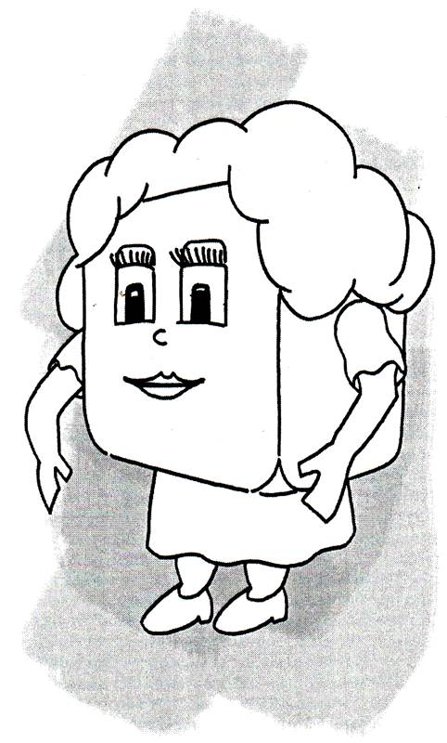
Billy was not too upset at being laughed at, because he had noticed that one of the ‘females’ who was dancing nearby, was looking straight at him, and smiling in a very saucy way. It gave him a funny feeling in his tummy, which was not at all unpleasant. Just then, ‘she’ (as Billy later learned was the correct way to refer to females) stopped dancing, and brought her partner over to where Billy and Monty were standing.
“Hi! Monty,” she said, but looking at Billy, “Aren’t you going to introduce me to your friend?”
Well, had Billy been around the Sound Board for longer, he would have recognised the question as being from the soundtrack of a thing called a film, where it had been used by a human girl who wanted to get to know the handsome hero. The female SB had obviously noted this so that she could use it herself when the occasion arose, and that appeared to be now! Although Billy knew nothing about all this, he was flattered to be the object of attention of someone who looked so nice, and he nudged Monty to get on with the introductions as quickly as possible.
“Oh! Sorry!” said Monty, “This is Billy.” Then facing the other way, he said to Billy, “This is Sue, and her brother Sam.” He turned back, “I haven’t seen you two for ages.”
“You should come and see us more often,” said Sam to Monty, “Not just when we have a party going on!”
“Well, you know how it is. Work, work, work!” said Monty, “But what’s the occasion for all the festivity?”
“Some of the Drivers who work with the Keyboard were up there when the human started cleaning it,” said Sam. “They managed to catch quite a lot of the cleaning fluid that was being used, and bring it back into the System. We got some of it from them, and a couple of our clever SB’s were able to extract the alcohol that it contained. It has a slight after-taste, which gives it an unusual flavour, but it does give a punch to our normal drinks. We just had to have a party, because everyone seems to get much happier and more relaxed when they have a little alcohol in their drinks. Here! Try some, and see!”
Sam moved over to a nearby table where there were some bottles and glasses, passed the glasses around, then pulled the bottle cork out of one of the bottles with a distinct ‘pop’. He poured some greenish liquid from the bottle into the glasses that the others were holding, then gestured to Billy and Monty to drink. Without any hesitation, Monty drank deeply from his glass, then smacked his lips and declared that it was the best batch he had ever tasted. Billy was a little more cautious, and only took a little sip. He found that the taste was a little peculiar, but still quite pleasant. With Sam’s encouragement, he drank more, and felt a warm glow spreading through his body as the alcohol started to have an effect.
“Don’t drink too much,” warned Monty, “You are not used to it like these SB’s. You will feel fine at first, but too much can make you feel terrible later.”
Billy promised to be careful, but before he could drink very much more, Sue invited him to come and dance with her. He tried to protest that he did not know how, but was told by all of the others that there were no formal steps, and that he should just move in time to the music. Without too much persuasion, he began to dance with Sue, swaying and moving his feet with the rhythm. Monty and Sam watched for a time, then they wandered off to find other mutual friends.
After a while, the very noisy music stopped, and a much gentler, slower tune was played. Billy looked around to see what was happening, and noticed that the other dancers were now holding on to each other, and moving in time together, rather than dancing apart as they had before. Sue moved closer, and put her arms around Billy, so he put his around her. At first he was afraid of stepping on her feet, but as she moved even closer, he found it was easy for the pair of them to sway gently to the music, almost moving as one. Billy found the whole experience quite delightful.
The rest of that evening passed very quickly for Billy, and in between having a few more drinks, he danced with two other females that came to join them with Sam and Monty. He enjoyed the slower dances more than the quicker ones, especially when he danced with Sue. Eventually, the lights were dimmed a little, and what was called ‘The Last Waltz’, was played. Billy found himself dancing with Sue once more, and as the music faded away, she squeezed him tightly, and got him to promise that he would come back to see her again. Most of the other SB’s started to leave, and Sue, Sam and the others went with them. As they all walked away, Sue kept looking back at Billy, and giving little waves of her hand, until they were gone.
“You seem to have made a quite a conquest there!” said Monty, nudging Billy in the ribs. “Sue obviously likes you a lot.”
“Well!” blushed Billy, “She did seem to be rather nice, and I did enjoy dancing with her.”
“I’ll bet!” responded Monty, then went on to say, “I don’t know about you, but I’m tired out! I think that we should find somewhere to have some sleep before we continue on our journey. It wouldn’t be a good idea to nod off whilst riding on the back of a Clock Cycle, that could lead to a nasty accident!”
Billy agreed, so the two of them walked back to the corridor, and wandered along – a trifle unsteadily, it must be said – opening doors and peering into rooms until they found one that looked as though it was where the SB’s took their drinks breaks. As well as some tables and chairs, there were several comfortable looking sofas in the room. They looked very inviting to the two tired friends, so, selecting one each, they gratefully sank into the soft cushions, and lay down to rest.
“Thanksh – Sorry . . . thanks!” said Billy, whose tongue seemed to have already started to go to sleep on its own for some reason, “That was a very nice party, Monty.” He yawned, and in a very drowsy voice, said, “It was good of you to take me along. I did so enjoy dancing with Sue and the . . . . “ – his words trailed off to a mumble.
There was no response from Monty, other than a gentle snoring noise. The pair of tired travellers gradually fell into the very deep sleep that comes after lots of exercise and several glasses of alcohol.

Chapter 6 A room with a view
When Billy awoke, as he opened eyes, it felt as though someone was shining a bright light into them, so he closed them again quickly. He tried again, more slowly, and realised that the light level was normal, but his eyes were very sensitive. Also, his head felt as though it was too full, as though he had two brains inside instead of one!
“Oooohhh!” he groaned, sitting up rather slowly since he felt as though he might fall apart otherwise. “My head!”
Monty was already awake, and was looking at Billy with an amused smile.
“I told you not to have too much of those alcoholic drinks,” said Monty, “You are not used to them. But don’t worry, you will feel better when we get outside, into the fresh air.”
Billy doubted that he would ever feel better, but nevertheless he followed Monty out of the room, and down the corridor back to the spiral staircase. If he had felt giddy on the way up, he felt a thousand times worse on the way down, and stumbled down the stairs whilst vowing never to drink alcohol again, ever! Eventually, they reached the bottom of the stairs, and Billy pleaded with Monty to let him rest for a moment, to get his head to stop spinning. Monty agreed, and told Billy to stay where he was for a few moments.
Suddenly, Billy felt cold water being poured over his head, and he gasped and spluttered at the shock. Monty was standing over him with a, now empty, bottle in his hand.
“I found some water in the cooling system for the Sound Board,” he said, “That should make your head clear.” Would you like me to get some more?”
“That’s quite enough,” said Billy firmly, feeling a little angry at being soaked. However, after a few moments he discovered that, surprisingly, the water had achieved the desired effect. His head started to feel more normal, and his eyes not hurt very much at all.
“Well, I suppose I should thank you,” said Billy, “But that was a bit of a shock.”
“Works every time!” declared Monty, confidently, “No need for thanks. You’ll be fine in a minute. I’m more careful now about drinking alcohol, than in my younger days. I remember once . . . . but I’d better not talk about that now, we should be getting on.”
They walked back to the side of the System Bus, and Monty got out his IRQ again. They had to wait for quite a time before a Clock Cycle to appear, so that it could be flagged down. (Although the time seemed quite long to Monty and Billy, it would have seemed to be less than a thousandth of a blink of an eye to a human, for those who inhabit the insides computers live their lives at a much, much faster rate. This is why they can perform their tasks so quickly, giving answers almost before a question has been completed.) When the Cycle stopped, Monty got the same look of interest as before from the riders when he said that they wanted to go to the CPU, but no other comment. They took up their positions on the boxes at the rear of the Cycle, then the machine accelerated away at the usual furious pace.
As the air rushed past his face, Billy began to feel a lot, lot better! His thoughts turned to Sue, and the hope that he would see her again. That started a train of thought that led to his impending interview with the CPU, and he wondered what his punishment would be, and whether he would ever be allowed to go anywhere again. Not being the sort of Bit who dwelt too much about things not in his control, however, Billy soon stopped worrying, and concentrated on looking at the different objects that they were passing. There were lots of blocks of all shapes and sizes alongside the track, and Billy could not even start to guess what they were for. However, when they started to approach another very large building, similar to the Sound Board, Billy’s curiosity forced him to call across to Monty to ask if it were another, and why there were two.
“No!” responded Monty, “That is the Graphic or Video Card. Where visual information is processed and sent up that cable to the monitor,” he added, pointing to a very thick cable rising out of the top of the building. I suppose that you’d like to take a look inside. Well, we are already late, so I guess that a little bit more delay won’t hurt.”
After they had asked the rider with the armband to stop, and had jumped down off the Cycle, they heard him muttering as he moved off.
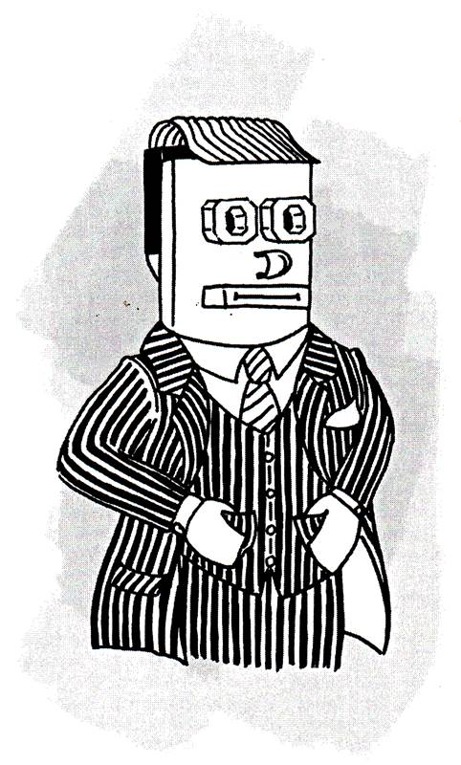
“Stupid Mail Messenger! Can’t make up his mind where he wants to go! Good job we don’t see them too often, we’d never get our normal work done!”
Monty gave no reaction to the comment that they had heard, just led the way to the door at the centre of the front of the building, and knocked on it.
“The Video Processors who work here are more formal than the Sound Boarders,” he advised, “So it’s best to wait to be invited in. They don’t like anyone wandering around unescorted in case they accidentally muck up their precious data. Very, very, particular are the VP’s, for they think that they have a major role in presenting information to humans. Because of this, some of the Sound Boarders say that the VP’s think that they are V-I-P’s, or ‘Very Important Processors’, but that’s just their fun. Anyway, be careful to treat them with respect.”
Just then the door opened, and they were greeted by one of the VP’s. He was dressed in a very smart pinstripe suit that had a matching waistcoat, and a handkerchief neatly showing in the top pocket of the jacket. Monty explained that they would like to take a look around, but the VP did not seem too willing to let them come in. It was not until Monty mentioned that they were on their way to see the CPU that the VP’s attitude changed, and they were then made to feel most welcome.

“I’ll show you around, myself,” said the VP. “My name is Victor. May I enquire what your names are?”
Monty introduced himself and Billy, but felt that it was better not to explain the reason why he was taking Billy to see the CPU. They shook hands formally, before Victor asked them to follow him into a room where there was a quiet hum of activity in the air as a number of VP’s went about their work.
“This is where the data from the System Bus is initially processed,” he advised. “Part of our complex here is a little like the System Memory, and in this room we decide where each Byte of input data has to go in this local memory area. We give addresses to the Bytes in this local memory that match the positions of each of thousands of points on the monitor screen. The information in each Byte determines whether the point should be dark or bright, and also what colour it should be. When this data gets to the monitor, the way that the colour and brightness of each point is set determines how the picture looks on the monitor. Although the points look quite large to us, they are very tiny to humans, and they just see the overall picture, rather than lots of individual dots.”
Victor led the way up some stairs, to a room which looked very familiar to Billy, for it was the local memory area, and was organised in a similar fashion to his own home in System Memory. He saw the individual Bits bobbing up and down as data was fed to them by their own ‘Mr Write’, who was busy carrying data from the room downstairs. Their ‘Mr Read’ was taking his data to a room above, but seemed to be reading from a whole row at one time rather than individual Bytes. When Billy asked Victor about this, Victor explained what was going on.
“Most CRT (Cathode Ray Tube) Monitors are not able to show all the points on their screens at the same time,” said Victor. “They have to show one point after the other along a row across the screen, then drop down and start at the beginning of the next row, and so on. When the bottom of the screen is reached, the whole process starts again from the top.”
“I see,” said Billy, so you have to send the information for all the points in one row across the screen in a group, and follow it by that for the next row down.”
“That’s right!” said Victor, who seemed pleased to have a visitor who seemed able to grasp what was going on, “And we add in special signals to show the start of a screenful of information, and the start of each row. They are called ‘sync’ – or synchronisation – pulses, and they help everyone involved to keep track of where we are.”
“But why do you keep sending the same information over-and-over again,” asked Billy.
“Because the brightness and colour of the points on the monitor screens fade fairly quickly, so we have to ‘refresh’ them all the time. Sometimes it happens as many as eighty times every second. We do it quite quickly – as far as humans are concerned – so that the points are refreshed before they fade completely, and the humans see an overall picture, rather than a row of dots moving down the screen. Images of things that they see, stay – or persist – for a while in their eyes, and this helps the process.”

“As you can imagine,” went on Victor, “This takes a lot of organisation, and information is moving around all the time. We have to work with the Drivers for each type of Monitor, to make sure that they can understand and cope with the information that we send out.”
“Oh! Yes!” said Billy, “I’ve heard about Drivers before, but I suppose that you work with different types than those on the Keyboard and Soundboard.”
“True!” said Victor, “But we shall soon have to get used to working with new types of Drivers, and re-organising the whole way we work. There are new types of Monitors being used with systems now, called TFT LCD’s. That stands for ‘Thick Film Transistor Liquid Crystal Displays’, and they can show all the points on a picture at the same time. We only have to send information about points which change their colour or brightness, rather than having to send information for all the points over-and over. As far as the humans are concerned, they are better, as they get no flickering at all, and they like these new screens because they are slimmer than the CRT versions. We are really going to have to make lots of organisational changes here to be able to cope with these new Monitors though, and I must say that I’m not looking forward to it. Still, that’s enough about my worries, let’s go and look at some of the test screens that we have here and see some of the images that we show.”
Victor then led Monty and Billy on a tour through more of the rooms in the Video Card, and they looked at lots of different types of pictures on the test screens. Some of the things that they saw could not be understood by Monty, let alone Billy, with strange sights, animals and moving patterns that dazzled their eyes. When they asked Victor about some of the more strange scenes, he replied that that it was impossible to understand everything that humans do, their world was so large and varied that it was largely incomprehensible to computer-dwellers.
“We have to assume that the information we are dealing with makes some sense to them,” declared Victor, “But I have to admit that it often leaves me baffled!”
At the end of the tour, Billy and Monty thanked Victor for his kindness, but he waved aside their thanks, saying that it was stimulating to talk to those who showed a real interest, and were not just doing the ‘grand tour’. He gave Billy and Monty a pen each, which were engraved with the name of his company – ‘Matrox Millenium’ – and which he said could be momentoes of their visit. After shaking hands again, and with more thanks, Billy and Monty left Victor at the door of the building and made their way back to the System Bus.
“What a nice chap.” said Billy when they were out of earshot. “He really made us welcome.”
“Yes,” replied Monty, “But mentioning the CPU certainly helped. Talking of whom, we had better get a move on, or we shall never get there. Luckily it’s not far now, so we can probably walk the rest of the way. Come on – the last one there’s a cissy!”

Chapter 7 Up to no good!
Monty raced Billy to the comer of the Video Card building. Despite Monty having started before Billy had realised he was being challenged, Billy was determined not to be beaten, and they arrived together. They rounded the corner, and as they stood there, each catching his breath, Billy could now see several more buildings. In the distance was a very large, square structure, with lots of metalwork on top, but nearby were four smaller, long rectangular buildings, three of which had cables emerging from their roofs.
"More Component connections?" enquired Billy, pointing at the nearby buildings.
"Yes," replied Monty, 'These are for the Hard Disk, CD ROM and Floppy Disks."
"That's only three," said Billy, "why is there one more building?"
"It's to cater for expansion - if the System needs another Hard Disk, it can be linked to the empty building," answered Monty.
"You talk about Hard Disks, and Floppy Disks," said Billy, "But what are they, and what is the difference between them?"
"Both types of Disks are for storing information on a long-tem basis." responded Monty. "In the System Memory area where you live, information - or data - is stored on a more temporary basis, and is concerned with tasks that the CPU is actually dealing with at any time. On the Disks, data for use in tasks, or the instructions for actually performing tasks themselves, is stored there more permanently. Because there is much more data on the disks, it has to be stored in a very organised manner, and it is usually extracted again in large chunks, in the same organised way as it is put in."
"Why are two types of storage needed," asked Billy.
"It's all to do with how quickly things can be done," said Monty. "The information that you store, is needed very quickly so that a task is not delayed, and it could be from anywhere in System Memory. Because data can be taken from anywhere, this type of memory is known as Random Access Memory - or RAM. Disk memory access is not random, and is much slower because data is stored and retrieved in an organised way, and this takes more time. So it is used for data that is not needed so quickly, or is just too large to store permanently in System Memory."
"O.K., I think I understand," said Billy, "But why Hard and Floppy?"
"In the early days", replied Monty, "Removable disks were made of thin plastic, and were very flexible - or floppy! Nowadays they are protected by a thicker, fairly rigid plastic cover, so they are no longer really floppy, but the name has stuck. On the other hand, hard disk units are usually permanently fixed in the system, and the disks themselves are made from metal, with several of them are housed together in a sealed metal container. As a distinction from the smaller, removable types, these have become called 'hard' disks."

"Oh! I see!" said Billy. "You know, when you first mentioned Hard Disks during the first part of our trip, I did wonder if there would be 'soft' ones. I suppose that 'floppy' is just another way of saying the same thing. I do want to ask you about the CD ROM, but before you tell me about that could we take a look inside a hard disk?" he enquired, hopefully.
"Well, I suppose so," said Monty, "It shouldn't take long, but it depends whether I can arrange it. Let's get up on the roof and see."
There was a staircase at the side of the middle building, with only a short climb to the top. When they emerged onto the roof Billy could see that there were Drivers running up and down the building's cable, and Monty went over to talk to one who seemed to be supervising the others. Billy remembered that the Drivers carried information backwards and forwards for the Components outside the System, and guessed that the Disks must need the same sort of translation service. It was difficult to say why, but the Drivers certainly did look 'foreign' in some way - they were somehow 'different', but Monty seemed to be having no difficulty in making himself understood.
"The supervisor owed me a favour from when I helped him with some translation difficulties at the time his group first arrived," said Monty as he called Billy over. "And he has agreed that we can go up to the Hard Disk."
Billy watched the supervisor walk over to a storage shed, and return with a couple of sets of straps, joined together with metal clips and clasps.
"Zese are ze zafety 'arnesses," he said in a heavily accented voice. "Ze Rule iz zat you must wear zem!"
The supervisor helped Monty and Billy put the harnesses on, and fastened them tightly around their legs and waists, completing the job with a clip through a central pin. He led them over to the base of the cable, and stopped two of the other Drivers who were about to climb up, by tapping them on their shoulders. There was some conversation between the three, and Billy heard some comments about "Bonuz" and "Ze overtime", but eventually agreement seemed to be reached. There was a large quick-release buckle on the front of Billy's harness, and the supervisor attached this to a ring on the back of a similar harness that the nearest Driver was wearing. He then repeated the process for Monty and the other Driver.

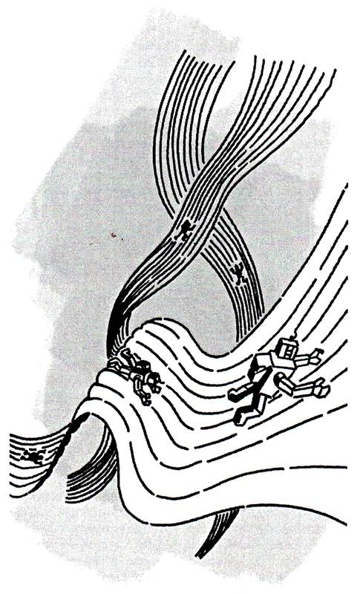

At first Billy though that he and Monty were just going to dangle below their respective drivers, but the supervisor gestured that they should climb on the backs of the Drivers, and hold onto their harness - just as though they were being given a piggy-back. This they did, and without any further ado, the Drivers set off up the cable, not appearing to be affected by the extra weight of their passengers.
As they climbed, Billy could see that the Drivers had very strong arms and legs, both of which ended in very strange 'hands'. Each only had one wide 'finger' and an equally wide 'thumb'. In the short moments when their 'hands' were taking a fresh grip, Billy saw that the inner surfaces were covered with ridges, which obviously helped them to get a very tight grip on the cable, and prevented them slipping. After they had climbed for a while, Billy took a look down, and then wished he had not! They were now very high above the building, and Billy shuddered at the though of falling all the way down. He quickly looked upwards again, and reassured himself that the Drivers obviously did this sort of thing all the time, and the safety harness appeared very strong and in good condition. Nevertheless, he was very glad when they reached to top of their climb, and entered a large metal enclosure through a window over the top of the cable attachment point. After they had unclipped, and removed their harnesses, Monty invited Billy to come back to the window, to take a look at the 'splendid view', but Billy declined the offer. He assured himself that he was not realty frightened of heights, but he had seen quite enough on the way up!
Monty thanked the Drivers, then led Billy to a door with a lever and a spoked wheel on its front. He moved the lever, then spun the wheel, before trying to open the door. He needed Billy's help with this, for the door was thick and heavy, and had rubber seals around the edge that became visible as it opened. Through the doorway, they entered a small room, which only appeared large enough to contain three or four people. It was featureless, apart from a control panel on one wall, and a similar door to the one by which they had entered, on the other side. Monty got Billy to help him pull the door shut again, and then reversed his actions with the wheel and lever. When the door was firmly secured, Monty moved to the control panel on one wall, and pressed three buttons in turn. A red light appeared, and there was a hissing noise. Billy felt his ears 'pop' as the pressure of the air in the room changed. The red light on the control panel went off, and a green one came on. Monty pressed another button on the control panel, and a part of the plain wall swung open, revealing clothes hanging on pegs.
Monty handed Billy an all-in-one suit which was made of a transparent material, and which had boots and gloves joined to the ends of the legs and arms. Following Monty's example, Billy put his suit on, pulling a hood which sealed around his face over his head. They helped each other doing up long double-seal zips at the fronts of their suits, then stood there looking at each other solemnly. This did not last for long, however, as Billy - and then Monty - burst out laughing at the funny sights that they presented.
"What is all this about," gasped Billy, as he tried to stop laughing. "Why are we dressed in such a peculiar fashion, and what's this room?"
"This 'room' is an airlock," replied Monty when he had regained control of himself. "And the suits and the airlock are to protect the very clean area where the Disks are. The slightest amount of dust or dirt that got inside could cause terrible damage, so precautions have to be taken against anything unwanted entering. You'll see why in a moment."
He moved to the other door, and they went through the procedure with the lever and wheel to open the door, finally emerging into a very large brightly-lit area. It was spotless! The walls were gleaming metal, and there was not a speck of dust to be seen. In the middle of the room were a number of large shiny round metal disks, spinning on a central spindle. Despite their large size, there was no vibration due to the spinning, nor any noise. There was just a quiet hum in the background, probably from whatever was keeping the disks going round. Each disk had an arm mounted above it. The arms could turn on a separate spindle, so that the inner ends of the arms could move in arcs over the disks. Billy bent down to look under the lowest arm, at the tiny gap between its inner end and the surface of the disk.
"What's holding the arm up?" asked Billy, for there seemed to be nothing to stop the end of the arm from dropping onto the disk.
"Air!" said Monty. "The gap is so small, and the surface of the disk and the arm end are so flat, that the arm end floats on a cushion of air. Now you know why no dirt or dust is allowed in here. A particle of dust would be enormous compared with that tiny gap, and if it became trapped beside the end of the arm, it would scratch and damage the flat surface of the disk, and prevent the arm’s ends from floating. Even the mark left by a human's finger would jam the arm end onto the disk, and ruin the surface."
(Billy and Monty could see the gap between the arm and the disk quite clearly, for to them it appeared small, but not that small. It has already been mentioned that those who dwell inside computer systems live at a much faster rate than humans, but it should also be remembered that they are extremely tiny! It would be very hard for a human to see a computer-dweller, and even more difficult for a human to see the gap that Billy and Monty were examining so easily.)
Just then the arm just above the one that they were looking at started to move. It swung to a new position, nearer to the inside of the disk, and the end started to glow. Monty took the metal cylinder of his IRQ kit from his pocket and tapped the end on the floor to extend it. Holding it tightly so that it could not be pulled from his grasp, he demonstrated to Billy, that the end was alternately attracted to, and repelled from, then end of the glowing arm.
"That's magnetism, that is!" declared Monty. The force that makes some things attract iron and steel, and which makes compasses work. The surface of die disk is being magnetised in some spots and not in others as the disk spins under the arm. Where the disk is magnetised represents a one and where it is not represents a zero - much like you standing up and down in System Memory."
"How clever!" said Billy. "Does the magnetism last for a long time?"
"Ages!", declared Monty, "And at any time, its state can be read by a same part on the end of arm that puts the magnetism there in the first place. Instead of the rows of memory that are familiar to you, the data here is stored in rings, or tracks, and there are thousands of separate tracks side-by-side all over the surface of each disk. There's a control room nearby, where the organisation of the data is controlled by the equivalent of your Mr Read and Mr Write. The data they deal with is carried backwards and forwards by the Drivers who gave us a lift up here, as it goes to and from the System Bus and the CPU.”
"There must be the capacity for storing huge amounts of data here," said Billy, shaking his head in wonder. "When I saw all of the System Memory area I thought that was big, but this is just, just huge” - he struggled to find words to describe the enormity of what Monty was telling him.
"This is not that big," advised Monty, "There are lots of Hard Disks bigger than this one. And the humans are improving them all the time. They are making disks where the magnetic areas can be closer together, and the tracks more tightly packed, constantly improving the capacity for storage. They have been doing this for years, which is why, in the early days, a ten Megabyte disk was considered quite large, but now ten GigaBytes is considered fairly small. As a Gigabyte is a thousand Megabytes, you can see that they have made a lot of progress. When they put several disk systems together they now talk of TeraBytes, which are millions of Megabytes!"
All the way back through the airlock room, where Billy and Monty left their 'clean' suits, Billy thought about all he has heard about hard disks. He tried and tried to visualise the massive numbers of Bytes of storage area that Monty had spoken of, but in the end just had to content himself with using the same word as before - 'huge'. When they arrived at the window above the cable down to the main system, he was still pondering on the subject, as he put on his safety harness. He had watched when the supervisor had strapped him in earlier, and thought that he was following the same routine, but because of his lack of concentration on what he was doing, he missed one vital step. He forgot to insert the locking clip that held the whole harness together. All the ends were fined to the central pin at the front of the harness, but the locking clip was not pushed through its hole. Monty had been busy trying to get to Drivers to agree to take them down, so he did not notice Billy's error. When he finally found two willing Drivers, they were in rather a rush because of the delay talking to Monty, so they just checked to make sure that the quick-release buckles were properly attached to their harness rings before taking their two passengers on their backs and starting the descent.
The procedure for descending the cables was quite different to that for climbing. With complete unconcern, the Drivers simply let the cables slide through their hands for a while, so that they, and their (astounded in Billy's case) passengers, descended at an ever-increasing rate. At some point when they felt that they were starting to go too fast for safety, they gripped onto the cables and slowed nearly to a stop. They then released their grips and started accelerating down again. Unfortunately, this rather jerky motion tended to shake their passengers about rather a lot and their harnesses were alternately loosened and tightened as the sliding and braking actions took place. Billy eventually started to relax, and began to think that they were probably far enough down the cable for him to take a look around without being frightened by the height. He loosened his grip on the Driver's harness so that he could turn away a little from the back of his Driver and take a look around when his Driver suddenly decided to brake rather violently for some reason. Billy's grasp slipped from the Driver's harness, and the combination of this and the sudden braking caused his own harness to spring undone under the strain as there was no locking clip to prevent it. Billy immediately separated from his Driver, and started to fall free. He was too shocked to scream!
Chapter 8 Down and Out
If Billy had felt bad when he awoke that morning after the party on the Sound Board, it was nothing to how he felt when he finally recovered consciousness after his fall. It was as though he had been ridden over by a thousand Clock Cycles – all fitted with spiked tyres! Every part of his body was complaining about the rough treatment it had received, and pains shot through all his limbs as he struggled to move.
“Don’t try to get up yet, Billy,” said Monty anxiously, “You fell quite a long way, but luckily the safety routines in force here saved you from really serious injury. You were caught by the Data Monitors, who have the job of ensuring that no accidents occur with data being transported to and from the Hard Disks. Unfortunately, their equipment is really only designed for information packets, not Bits like yourself, so I’m afraid you bounced around quite a bit on the plastic sheet they use for catching things. How do you feel?”
“Broken!” groaned Billy, but as he realised that he was not as dead as he had expected to be when he started to fall, he found that the pains were actually starting to reduce as his shocked system recovered. “What happened to me ?” he managed to enquire.
“We checked your safety harness, and it is not damaged, Billy, so we think that perhaps you forgot to put in the safety pin. I should have checked for you, so it is really my fault you were hurt. Please, please accept my apologies!”
As he realised that nothing was actually broken, and rather embarrassed at not having put the harness on correctly, Billy responded with, “No! No! Don’t worry Monty – no harm done really. I’ll probably have some picturesque bruises later, but otherwise I think I’m fine!” – this through gritted teeth! He got to his feet with some effort – and assistance from the Data Monitors – who he thanked effusively for saving his life.
“Just part of the job!” declared one. “Glad to help,” said another, although they did seem a little disappointed that Billy was all in one piece and there were no broken bits to gawp at. With slightly disgruntled expressions, they all wandered off to take up their posts once more.
“Strangely, they didn’t seem too pleased,” commented Billy.
“No, they do a good job, but nevertheless they were hoping for a bit of gore – people always seem to ‘enjoy’ looking at the aftermath of an accident, despite their expressions of sympathy for the victims,” declared Monty. “I think it’s just the same in the human world”.
“Well, I’m very grateful to them, but not really sorry to deprive them of the sight of me being carried away on a stretcher. . . . . . Shall we go?” enquired Billy.
“Are you sure you can carry on?” asked Monty. “You can rest for a while if you want.”
“No, no. Best if I move about, I think,” said Billy, but he did quietly wince every now and then as another muscle decided to complain about the harsh treatment it had received. “Let’s get on!”
“O.K. then, if you’re sure” replied Monty. “But if you need to stop for a rest, do say so.”
The two travellers walked for quite a while, and Billy began to feel much more comfortable as the gentle exercise relaxed his tense body. When at last he stopped concentrating on how he felt, he realised that he could hear the noise of rushing air. He looked up from the ground (which he had been studying carefully to ensure he did not trip over the increasing number of tracks that they were crossing and thereby fall and agitate his strained muscles) and saw they were approaching an enormous square, black building, formed by rows of strange metal sections. It was from the gaps between the sections that the air was rushing, and Billy felt its warmth on his face.
“At last, the CPU,” declared Monty, waving his arms wide.

Chapter 9 The CPU
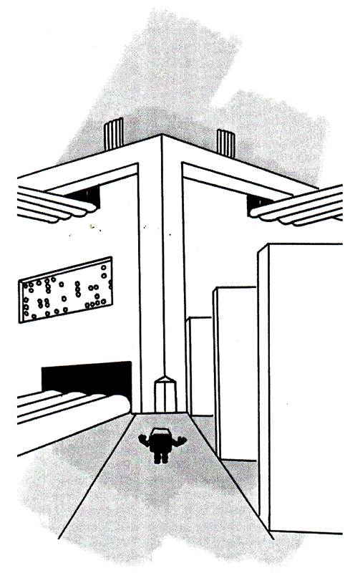
Billy looked up at the gigantic black building in front of him in surprise. He saw that the ends of the System Bus tracks ran into the building from one side, but that there were lots of sets of other, smaller, sets of tracks entering on the others. If he had been a human, he might of though it all looked like a massive railway junction with tracks everywhere, but as he was a Bit with no experience of the outside world, he just struggled to grasp the size of it all. “It’s enormous!” declared Billy, gazing in awe at the massive shape in front of him. “Just how big a brain has the CPU got? You could get twenty Memory Units in there!”
“Hold on!” said Monty, “It’s not all the CPU – only the ground floor!”
Billy looked more closely, and saw that the lowest part of the building was not made of metal sections, but was more like offices, with small windows under the overhang of the ponderous upper part.
“The top part is just the heatsink and fan,” shouted Monty above the noise of the rushing air. “The noise you hear is from the fan in the middle, as it draws cooling air over the metal sections clamped to the top of the CPU building and so conducts heat away from the CPU. This contraption is needed to keep the CPU from melting from the heat generated by all the processing that is being done here. If the fan ever stops, the whole CPU may suffer from heat exhaustion, and the whole system will grind to a halt. But let’s get inside – out of the noise.”
Monty led Billy to a glass door in the wall of the lower building, then took a shiny card from his pocket and slid it through the slot of a device on the wall by the door. With a click and a hum of automatic mechanisms, the door opened for himself and Billy to pass through. After they had entered, the door closed again, totally shutting out the outside noise. The silence was almost a shock after the noises outside, and when Monty spoke he unconsciously almost whispered.
“Security is very strong here,” he muttered, “Can’t even get through the door without a Pass, and even then you have to satisfy that security chap over there that you have an appointment, or you get no further.”
Monty walked over to the desk where the security officer sat, and was obviously confirming the details about himself and Billy. That left Billy himself free to gaze around at the grand entrance hall. There was a huge sign high up on one wall with the word ‘Intel’ in raised blue and silver letters, and there were a number of spotlights directed at it so that it dominated the whole hall area. There were other smaller signs with their own spotlights lower down and they appeared to have details of medals and awards that had been presented to the CPU for things like ‘processing speed’ and ‘data handling capacity’. Not many made any sense to Billy, but they were very impressive, and he began to get very nervous about meeting the person who had received all these distinctions, and who was obviously considered very important by lots of people.
Monty returned from the desk, holding two clip-on badges – one for himself and one for Billy – which he attached to their jackets. Billy was surprised to see that his badge had a picture of himself sealed inside, and seeing it, began to realise just how well organised everything was at the CPU.
“Keep this visible at all times,” warned Monty, “If the officers of the Security System can’t see it, and think you are an unauthorised intruder, they’ll use the ‘End Task’ routine to deal with you – and that’s not funny!”
Billy decided he really would prefer to remain ignorant about the ‘End Task’ routine, and made sure that his badge was well and truly clipped on, and would not fall off accidentally. He walked behind Monty as he motioned for Billy to follow him to one of a row of doors set down one side of the large entrance hall. When they reached the door, Monty waved his badge at a glass window beside the door, and a sign in the window glowed: “Accepted - Next”. Following Monty’s lead, Billy waved his badge, and the sign changed to “Accepted – Two to Enter.” The door slid open noiselessly, and they stepped into a small office containing some filing cabinets and a desk. A very smartly dressed ‘female’ sat at the desk. Billy was quick to notice that the occupier of the office was a female, using the experience he had gained at the Sound Card party, and despite the fact that ‘she’ was wearing a formal business suit. Somehow she fills it differently to a man, Billy thought, and she’s so beautiful …. and the smile she is giving me is dazzling. . . . He came out of his daydream only slightly as he realised that she was addressing him.
“Ah! Mail Messenger Montmerency! And you must be Mr. Bit – ‘Billy’ isn’t it?” she said in a rather officious voice. “I am Wanda, the CPU’s Background Operations Secretary. You are expected, so go right through.” - She pointed to another door on the opposite side of the room to the one by which they had entered. She turned back to her desk after Monty had thanked her, and seemed to have no further interest in Billy. Monty ushered Billy though the second door – with some difficulty because Billy was having trouble dragging his gaze away from the lovely Wanda.
“Behave yourself!” Monty hissed to Billy, “Stop staring. You don’t stand much chance with her anyway – not as just a Bit. She would only be interested in System staff at her own level or higher. I even had difficulty getting to talk to her myself,” he added with a rueful smile. “Anyway, thoughts of pretty females are not what should be occupying your mind right now, you should be concentrating on your impending interview with the CPU. Your whole future is at stake!"
Monty’s words finally stirred Billy out of his reverie, and with a last backward look as he went through the door, he entered the domain of the CPU. This turned out to be a great hall, with a curved ceiling so that no internal supports were needed. The hall was lit by yellow lights hanging from above, and there was a huge illuminated clock on each wall, but with only one hand and just four points where the hand paused. As the hands reached their pause points, there was a soft ‘bong!” noise that carried throughout the hall. To Billy, the interval between ‘bongs’ seemed to be what to a human would have been about ten seconds, but as has been said before, the occupants of computers work on a much faster time scale than humans. Beneath each clock was a sign with the legend “STANDBY” glowing on a yellow screen.
As Billy looked around further, he saw that there were different coloured sets of lines on the floor, leading from similarly coloured large floor areas around the sides of the hall. There were lots of individuals standing about in these areas, talking amongst themselves, but not looking particularly busy. Moving between these areas was someone sitting on the back half of a bicycle, the front of which had been replaced by a steerable box on two wheels – rather like an old-fashioned ‘Stop me and Buy One’ human ice cream seller’s trike. He was taking numbered plastic cards from the box and giving them to some of those standing in the coloured areas as he passed. At each bong of the clock, Billy saw that one of the card-carriers started out along the coloured lines – which led to the centre of the hall. At the centre there was a raised platform with separate rows of steps leading upwards from the ends of the sets of coloured lines. In human terms, it looked like a queuing system was in operation, rather like that used at the ‘deli’ counter in Tesco’s, with the card-carriers taking their turns in the order decided by the trike rider.
When the card-carriers reached the platform, they climbed their own set of steps, and approached the occupant of a large chair. On the chair sat a person dressed in blue robes lined with silver, the same colour combination that Billy had seen on the ‘Intel’ sign in the entrance hall. As Monty led Billy along one of the sets of lines towards the centre of the great hall, he quietly passed on information about some of the things that Billy was examining.
“They’re the System Clock dials,” said Monty pointing upwards, “And the lines on the floor act as guides so that no-one bumps into anyone else as they move backwards and forwards.”
“It doesn’t look as though there would be a problem,” queried Billy, “There seems to be little chance of collisions at the moment.”
“That’s because the System is in ‘Standby’ condition at present,” responded Monty. “You wait until we go ‘Live’, then you’ll see some action! It goes mad in here when there are a number of Programs running at once.”
“Are the numbered cards designed to help?” enquired Billy.
“You do pick things up quickly,” declared Monty. “Yes, the trike rider is The Scheduler, and he helps the CPU by setting the order in which to deal with the various tasks in the most efficient way. The CPU is very fast, but if things are not organised properly, time can be wasted unnecessarily. Each of the coloured areas is for a different Program that the human User is running at the same time, and each Program has to share the CPU’s time according to the priority set by The Scheduler.”
“That set of thirty-two black lines in the middle of the far side,” continued Monty, “Are for information coming and going from the System Bus, carried by the Clock Cycles to other Components of the System – you remember?”
Billy well remembered his hair-raising rides on the Clock Cycles, and now began to realise why he had seen so few of them moving on the System Bus. It was obviously because the System was in ‘Standby’, which must mean that it was a time when not very much was happening, and not much data had to be moved about.
“Yes I certainly do. What is that rather dimly-lit area over there?” asked Billy.
Oh! The white area which looks a bit dusty!” exclaimed Monty. “That’s for DOS Programs – they’re rather old-fashioned now, and so it doesn’t get used much. Some of the workers there haven’t done a stroke for ages, but they have to be kept on just in case the User decides to run one of his ancient games. I seem to recall hearing about something called ‘Space Invaders’, but I’ve never actually seen it working.”
On one side of the black lines Billy could see a number of tables with operators controlling the positions of set of indicators mounted on the desks. On the other side was a fenced off zone which appeared to contain a small memory area like Billy’s home.
“The tables are the Registers, which the CPU uses for counting, and the fenced-off zone is the System Cache,” advised Monty when he saw where Billy was looking. “Rather like your home, but much smaller, and only used for very temporary storage of data. So you see, the CPU is really not just one person, there are lots of background workers and facilities to help with the processing. But the CPU is the one who makes it all work, and without whom the whole System could do nothing”
As they got quite close to the platform and the raised chair, Billy’s legs started to wobble a little as he realised just how powerful the CPU must be, and he began to regret having started his boredom protest in the first place. It had been very interesting travelling through the System, and he had enjoyed some good times on the way to the CPU, but what was going to happen to him now? All his original bravado was leaking away, and he gazed up at the occupier of the chair in a great deal of trepidation. He could see that this person had a very, very large head – which was understandable Billy thought, as there had to be lots going on inside. As he looked closer, though, he realised with a start, that this was not what he had expected. The CPU was not a male like all the other senior controllers of the System Units, ‘it’ was a female!

Chapter 10 Judgement!
“Shut your mouth, Billy,” hissed Monty in Billy’s left ear. “You’re gaping!”
“But! . . . But!” mumbled Billy, in a state of confusion – for he was totally unprepared for the CPU to be a female. He had naturally assumed that, like all the other senior personnel he had met during his travels, the CPU would be a male – though no one had ever said as much, he now realised. It had just been a somehow natural assumption to make.
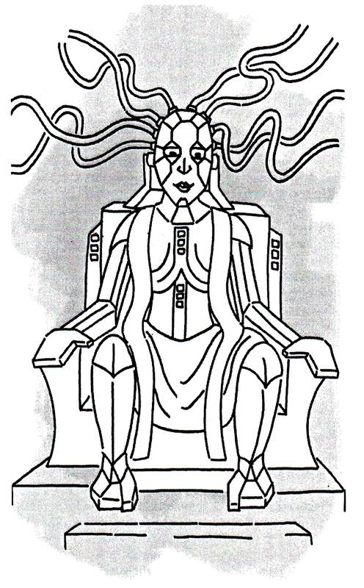
“You seem surprised, young Billy,” said the CPU – in a strong but not unkind voice. “Never expected to see a female sitting in this chair I expect.”
“Well! I er, er,” stuttered Billy, rather lost for words.
“Call her Ma’m,” whispered Monty, “And don’t try to fool her, she’s too clever for any of us! Be very careful what you say,” he warned.
Billy tried to pull himself together, though the worries he had felt about his situation were now building up inside, and he felt extremely nervous. But he was a plucky little Bit, and his natural strength of character enabled him to answer in a fairly firm voice, “Yes, Ma’m, I must admit that I did rather expect you to be a male. Please accept my apologies if I have offended you, that was not my intention.”
“No need to apologise,” said the CPU, “It’s a quite usual response. But my job demands that I am able to deal with lots of things at the same time. Females are far better equipped for this than males. It’s just like in the human world – women can cook, feed a baby, do the ironing and argue all at once. Men can really only handle one thing at a time!”
Well, Billy did not understand all the references to the human world that the CPU had made, but even if he had, felt that it would not be prudent to argue the point.
“It does irritate me at times, though,” continued the CPU. “After all most the System is located on what is called the ’Mother Board’, so it’s really a quite logical deduction for anyone to make. If it had been called the ‘Father Board’ then your expectations would have been understandable – but it’s not! Anyway, the System Clock is ticking, so down to business.”
The CPU examined the details in a folder that she had been holding, and scanned through its contents at an amazing speed.
“So, Mr. Bit,” she declared. “You decided to become indeterminate.”
“I did get the right word,” thought Billy to himself as the CPU waited for his response. He decided that telling the complete truth was the best policy, for as Monty had hinted, if he lied he was sure the CPU would see though him.
“Yes, Ma’m,” Billy replied, “But I did not intend to cause trouble really, I was just bored.”
“Bored!” “BORED!” shouted the CPU, “Who do you think you are? Lowly Bits aren’t allowed to worry about being bored!”
“Well, I’m sorry Ma’am”, replied Billy stiffly, “You asked me a question, and I answered it truthfully. I could have made some excuse, but I think you are too intelligent for me to try to fool you.”

“Well!” said the CPU, “Not afraid to stick up for yourself, I see. And capable of adding a bit of flattery as well. But what do you think would happen to the System if Bits like yourself decided to do what they liked? Can you imagine the chaos that would ensue? The System would collapse!”
“I understand that now, Ma’am,” said Billy, “But in my quiet corner of the System, it seemed such a small thing to do. Now that I have seen more of the System, and understand some of what is going on, I realise my mistake – but I was bored!”
“Hmmmm!” muttered the CPU, “You say that because of what you have seen you understand some of what is going on? Did you not come straight here?” she asked sternly.
“Er, No!” said Monty, “The request was only at Priority 4 level, so as there was no rush, I decided to show Billy some of the System on the way here.”
“Did you indeed?” queried the CPU, turning her steely gaze on Monty. “And who are you to make such a decision, a Scheduler?” she asked sarcastically.
“No Ma’am, just a Mail Messenger,” said Monty stiffly, “but there was a Directive issued saying that any staff showing aptitude for learning should be encouraged. I was following those instructions, and feel sure I was right to do so!”
“Ah! Another brave one!” responded the CPU gravely, “I do remember issuing that Directive when there was a shortage of staff at higher levels, but the point is, did Mr. Bit here actually show any promise?”
“Oh! Yes!” said Monty eagerly, “He picked things up very quickly, and even worked out some things for himself before I had a chance to tell him.”
“That’s true! I did!” said Billy vehemently, for he did not care if the CPU thought he was bragging, he just wanted to back up his friend, for it seemed from what the CPU was saying that Monty might be in just as much trouble as Billy. “I don’t care what you do to me, but Monty here was only letting me look at places because I had asked him. You can’t punish him for that!”
“Hold on, hold on!” laughed the CPU leaning back in her chair in a sudden change of mood, “No one is going to punish either of you. You have to realise that I just need to get at the facts of any situation quickly, and so sometimes I do seem a little harsh in my attitude. However, I find a tough approach tends to get the truth out in the open rather more quickly than any other way. My time, after all, is very valuable,” she added with a modest smile.
Billy’s face became less red as he digested the CPU’s words and rapid change in manner and he began to calm down a little. “But why did you have me brought here, if I am not to be punished?” he persisted.
“Because any member of the System who shows any inclination to rise above the general level of his or her duties is of interest to me,” said the CPU with a smile. “They can sometimes be trained to perform the higher level functions which are always being asked of us as the System is constantly upgraded by the human owner. But don’t get me wrong,” she continued, “All the members of the System are needed for it to function correctly, for even I could do nothing without the support of everyone else. Don’t underestimate the contribution you were making even in your ‘quiet corner’ as you put it”
“I see,” said Billy feeling slightly squashed, “But why did you seem so nasty just now?”
“Partly because I need answers quickly – as I said before – but also because I needed to know if you were truthful, intelligent and, most importantly, could stand up to pressure. It can be quite stressful having a more demanding job that that of a Bit in a memory area. The question was, could you stand it?”
“Loyalty is another important character requirement,” she went on, “For the System needs each element to support all the others when things get difficult, so I also needed to see what you would do when I appeared to be threatening Montmerency here a little.”
“Sorry, Billy,” added Monty, putting his arm around Billy’s shoulders, “I knew what the CPU was doing and played along with her. I had to go through a similar ordeal before I became a Messenger.”
“Well, I suppose it makes sense,” responded Billy who was now beginning to feel rather pleased with himself because he had not been intimidated, and seemed to have reacted in the correct way to his tests. “I guess that there must be situations where panicking could cause someone to do the wrong thing, and the System would produce the wrong results.”
“Exactly!” declared the CPU. “ - You were right Montmerency, he does pick up ideas quickly.”
“Thank you Ma’am”, said Billy, standing a little straighter. “But just what is going to happen to me now?”
“If you want to advance in the System – as it appears that you certainly do - you will have to join the Training Program,” said the CPU. “But hold on, I detect a change in the System occurring”, she said as she turned away from the slightly. “Back! Out of the way, both of you. As quick as you can!”
Billy felt rather hurt at being dismissed so abruptly, but had no time to dwell upon his feelings as Monty grabbed his hand and dragged him back along the floor lines towards the side of the hall. On the way, Billy noticed a figure carrying an IRQ with its red flag fluttering as he ran in the other direction, back towards the CPU. Moments later, alarm bells somewhere began to ring extremely loudly, so it would have been impossible to get Monty to hear any questions he wanted to ask. The noise was overpowering, and Billy saw that the ‘Standby’ signs had changed from white to yellow and were flashing on and off. They reached the side of the hall, and Billy tried to get his breath back.

Suddenly the ringing noise stopped, and an eerie hush fell over the hall. Everyone was staring at the signs under the clocks, obviously waiting for something to happen. After a few moments, with a loud ‘ping’ noise, the signs turned red, and the word ‘LIVE’ began flashing in white letters. There was a sound like a long ‘Aaaaaah!’ noise as all the occupants in the room released the breath they had obviously been holding.
It was then that pandemonium broke loose.

Chapter 11 Running Live
The illumination in the great hall had suddenly changed from a subdued yellow to a bright white light that initially hurt Billy’s eyes. As he got used to the glare, he saw that signs had appeared above the coloured regions around the sides of the great hall, and the individuals in these areas were running around at great speed, passing notes to backwards and forwards between them. Others were zooming to and from the centre of the hall where the CPU was obviously dealing with queries and issuing instructions at such a fast rate that it almost defied belief. The rider of the trike, who had been moving leisurely around the outside of the great hall when Billy first arrived, was now whizzing around at a tremendous speed – hurling his numbered sheets at those waiting to approach the CPU like a human paper delivery boy. Billy could not understand how the situation in the hall could change so quickly, and how those rushing hither and thither did not crash into each other and kill themselves. They were certainly moving fast enough to do great damage if they did collide, but somehow they seemed to anticipate each other’s movements and there were no accidents. However, the noise of their chatter, the constant rusting of paper sheets, the squealing of the trike’s wheels on the polished floor, the noise of the feet of the runners, and the general whirl of activity in the hall made Billy’s head spin, but he began to feel a little homesick for his home back in the System Memory. At least it was quiet and peaceful there.
“Isn’t it wonderful?” exclaimed Monty waving his arms to encompass the frenetic scene before them, “We’re very lucky to be here when the system if going at full tilt. Look at all the programs that are running!”
He pointed in turn at some of the signs above the coloured regions around the great hall, and Billy read the names as he followed Monty’s pointing finger. Initially he had no idea to what each referred as Monty read them out loud, but Monty’s added comments gave him some clues.
“There’s Outlook – that helps humans organise themselves,” said Monty, “And Word for writing letters. He must be using the Internet, for there are Internet Explorer and Outlook Express,” he added.
Monty went on reading out the names, but Billy’s brain had become overloaded with information. He wondered what an ‘Internet’ could be, and how a computer program could organise a human, but did not wish to appear too ignorant, so contented himself with nodding in apparent agreement to the enthusiastic Monty. However, he started to wonder whether he had done the right thing in apparently trying to get himself promoted, for it did all appear extremely complicated.
“Well, we’d better not hang around here I suppose,” said Monty rather sadly, for it was obvious that he would have like to do nothing better than to stay. “Let’s get you signed up for the Training Program. We’ll have to go back and see Wanda.”
The thought of seeing Wanda again brought about a sudden change in the direction of Billy’s thoughts.

“If I am on the Training Program, and can eventually pass whatever tests they set, and become a more important member of the System,” he said to himself, “It may be that Wanda will take more notice of me. Then of course, there were those rather nice females on the Sound Board, they were nice to me, but I saw that they were all rather more interested in Monty. Perhaps if I get to be a Mail Messenger, or even achieve a higher position, I could do rather well there. Besides, Monty thinks I am bright enough to start the Training Program, so if I work hard it shouldn’t be too difficult. I have already learned a lot since I started on my journey, and didn’t find things too complex for me to understand. I’ve had lots of adventures already, and there could be lots more in store. Yes, all in all, I think I should be all right!”
“Right! Monty my friend,” declared Billy, giving Monty a hearty slap on the back, “Lead on to Wanda and the Training Program. “I rather think I am going to enjoy my chance at a new career!
“OK, OK! Take it easy, said Monty, “You’re stronger than you think,” he said as he staggered under the impact of Billy’s heartiness.
“Sorry!” said Billy absently, as they walked a few more paces. Then he turned to Monty with a dazzling smile and asked, “But do you know what?”
“No! What?” asked Monty, also smiling at his friend’s newly found air of confidence.
“I’m NOT bored at all!” shouted Billy at the top of his voice.
The End
Table of Contents
Chapter 1 Rebellion!
Chapter 2 Facts and Figures
Chapter 3 The Main Road
Chapter 4 Sightseeing
Chapter 5 Time for some Fun!
Chapter 6 A room with a view
Chapter 7 Up to no good!
Chapter 8 Down and Out
Chapter 9 The CPU
Chapter 10 Judgement!
Chapter 11 Running Live

